VILOFT® and VISETA® BRANDING PROGRAMME

The branding programme has been established for the following purposes:
- To help our customers promoting the advantages of VILOFT® and VISETA®
to their customers.

- To ensure that downstream customers and end-users get the quality they expect.

- To prevent abuse of the VILOFT® and VISETA® brands.

The branding programme consists of three stages:

- Application: For new certifications, you send us the filled out application form and about
2 meters of fabric or 2 pieces of garment.

- Certification: We will examine the sample in our laboratories and certify the fibre content.

- Branding: We will send the hang tags to your address and you are allowed to use the brands.

Please note the following:

- A certification is only possible for fabrics containing a minimum of 25% VILOFT® or VISETA® to ensure the functionality of the blends. The certification is valid for two years from the date of certification.
- If you want to use our material for promotion (logo, scientific data, etc.), please inform us if and how you want to use it. All advertising and promotion material mentioning our brands has to be approved by the Kelheim Fibres marketing department in advance. We are happy to support you in creating promotion and advertising material – please contact us.

- Each different fabric or garment needs a separate application and will be awarded a unique quality number (i.e. VQ1234).

- Once a fabric or garment has been certified, that product should be produced to the exact specifications noted. If any changes are made in processing route, blend levels or dyeing and finishing the fabric should be re-submitted to be given a new quality number (VQ).

- Any change made to products without the prior knowledge of the Kelheim Fibres Marketing Department may result in garments which do not conform to the branding criteria.

- When the VILOFT® or VISETA® logo is used in conjunction with another brand, it is important to ensure that the VILOFT® logo has equal prominence.

- We reserve the right to take legal action for the unauthorized use of the VILOFT® and VISETA® brands.

For questions and further information, please contact:

Kelheim Fibres GmbH
Marketing Department
E-mail: branding@kelheim-fibres.com
Web: www.kelheim-fibres.com

VILOFT®/VISETA® - CERTIFICATION AND TAG APPLICATION FORM
Please switch to the editing mode of Microsoft Word for filling in the form.

1. APPLYING COMPANY
Company name
Click here to enter text
Address (new line with Shift+Enter)  Click here to enter text | Contact name  Click here to enter text
Email
Click here to enter text
Phone Number
Click here to enter text

2.1 NEW CERTIFICATION OR RE-ORDER
If your fabric or garment is already certified with a VQ number and you want to reorder tags for this fabric or garment, please enter the VQ number below and continue at point 3. If the fabric or garment has not been certified yet, please continue with 2.2.
VQ-Number: Click here to enter text
Fabric Supplier: Click here to enter text

2.2 YARN AND FABRIC DETAILS
VILOFT®/VISETA®-yarn spinner:  Click here to enter text | VILOFT®/VISETA®-yarn composition:  Click here to enter text | Yarn count:  Click here to enter text

Fabric Supplier:  Click here to enter text | Style / Reference No. of Fabric  Click here to enter text | Fabric weight (finished) g/m²:  Click here
Total fabric composition
Click here to enter text

Please note that a minimum of 25% VILOFT®/VISETA® in the fabric is necessary in order to obtain a certification!

3. RECIPIENT OF CERTIFICATE AND TAGS
☐ Applying Company ☐ Other (please specify below)
Company name
Click here to enter text
Address (new line with Shift+Enter)  Click here to enter text | Contact name  Click here to enter text
Email
Click here to enter text
Phone Number
Click here to enter text

4. END USE
Underwear / Bodywear / Sleepwear | ☐ | Denim | ☐
Functional Active & Sports Wear | ☐ | Socks | ☐
Thermal Wear | ☐ | Other: Click here to enter text | ☐
Name of Retailer: Click here to enter text |  | Date of going into store: Click here to enter text

5. TAG REQUIREMENT
Please fill in how many tags of which language you want to order.

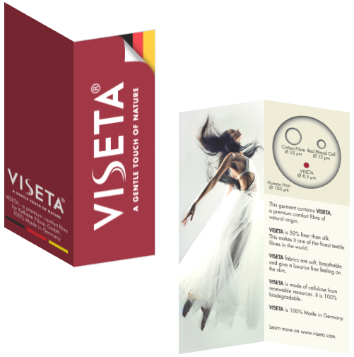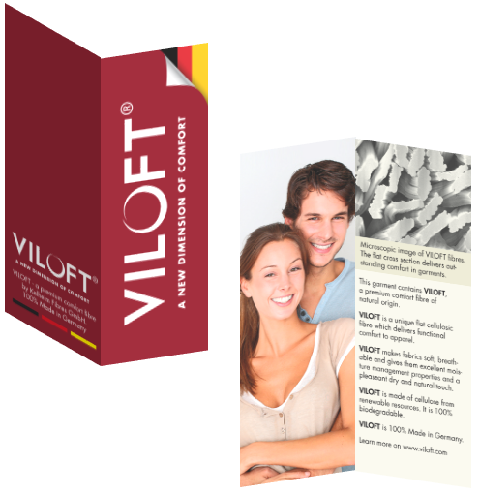

VISETA® Hang Tag |  |  | VILOFT® Hang Tag
German | Click here to enter text |  | German | Click here to enter text
Chinese | Click here to enter text |  | Chinese | Click here to enter text
English | Click here to enter text |  | English | Click here to enter text
Japanese | Click here to enter text |  | Japanese | Click here to enter text

Date: _________________ Signature: ________________________________

Please e-mail completed forms and send 2m of the fabric or 2 pieces of garment to:

Kelheim Fibres GmbH
Marketing Department: Branding
Regensburger Str. 109
93309 Kelheim
Germany

E-mail: branding@kelheim-fibres.com
Web: www.kelheim-fibres.com

